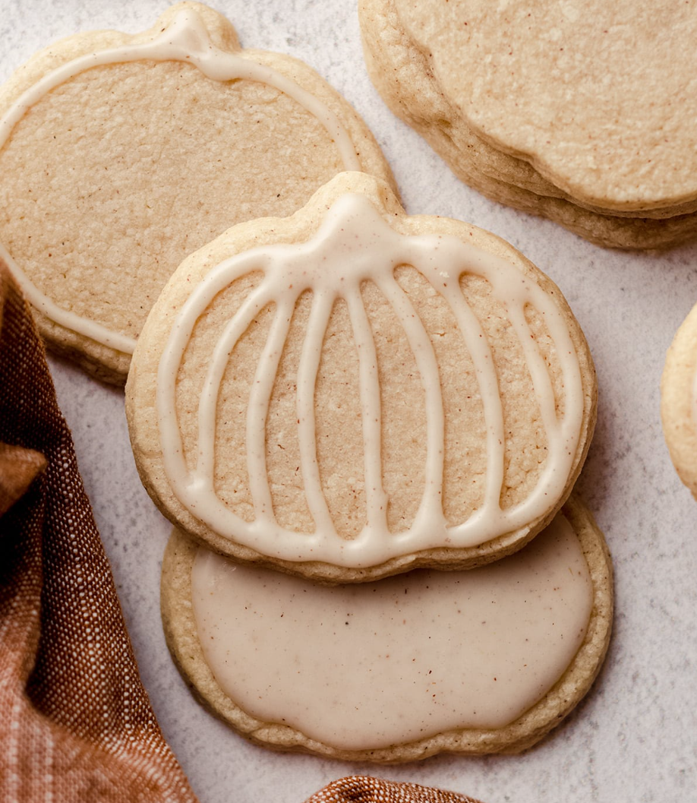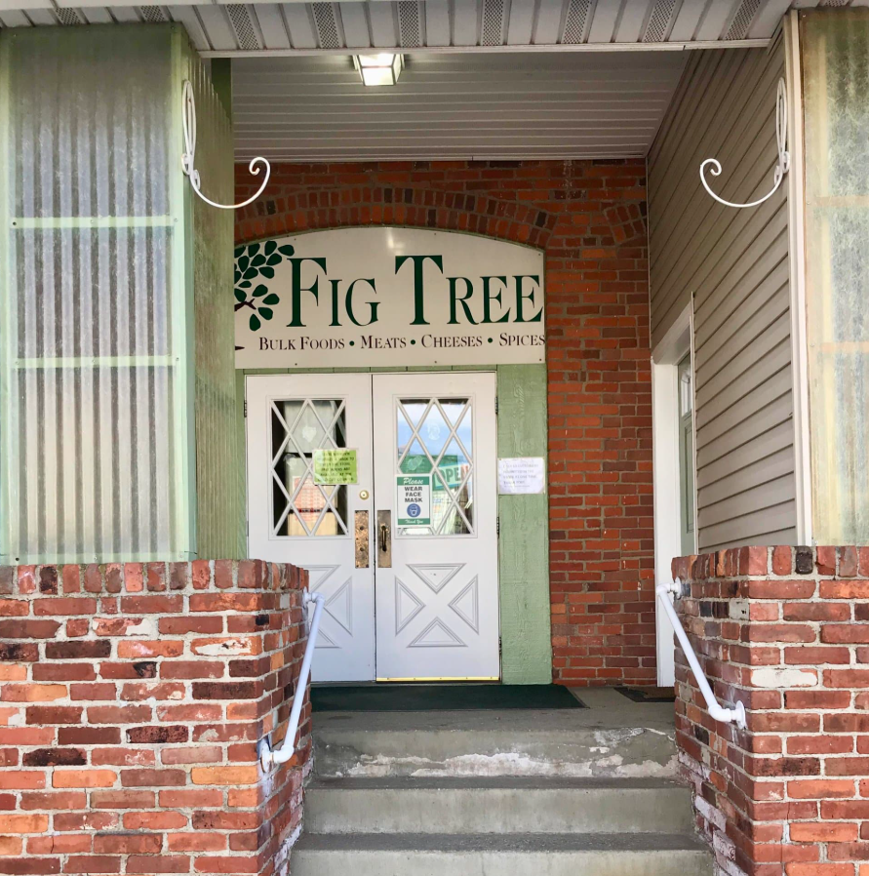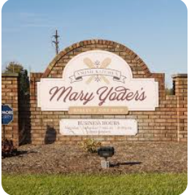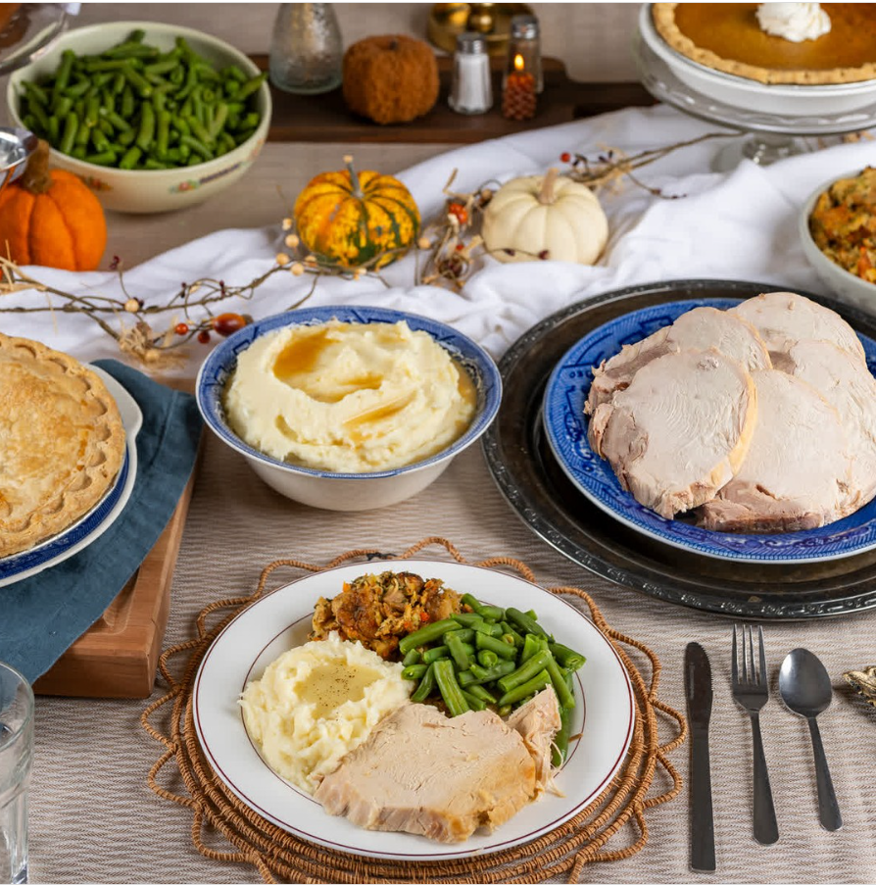
ANNUAL FALL BUS TRIP! The Spirit of the Season!
----------- Saturday November 7, 2026 -------------
It’s never too early to get into the Spirit of the Holiday Season! Travel to Middlefield Ohio where we will enjoy coffee and cookies in Mary Miller’s Amish Home, as she invites us into her bakery to decorate ½ dozen cookies to take home. Next, we will sample our way through Fig Tree Bulk Food Store* and have the opportunity to purchase those hard-to-find items at a great price. Then get your taste buds ready for a traditional Amish dinner back at Mary Miller’s Amish Home. We guarantee no one will leave hungry! Depending on the weather, we will then either visit John’s Country Nursery (johnscountry.net) or the End of the Commons General Store (endofthecommons.com). The final stop of the day is at Mary Yoder’s Amish Bakery and Gift Shop (maryyodersamishkitchen.com) where you will have time to purchase some Amish baked goods and browse for unique gifts.
Departing from The Episcopal Church of Brookline, 3010 Pioneer Ave, Pittsburgh (Brookline) PA 15226.
Cost is $189.00 - RSVP date is October 13, 2026
The lower hall of Advent Church will be open at 7:30 am for donuts and coffee. Bathrooms will be available. We board the bus at 7:45 am for a 8:00 am departure. There will be a comfort stop on the way. Estimated return time is 7:30 pm with a comfort stop if needed. Walking Code for this trip is rated a 3 (out of 4).
* Fig Tree is a store that carries bulk products (flours, sugars, spices, pretzels, noodles, etc) a large selection of candies, deli meats & cheeses.
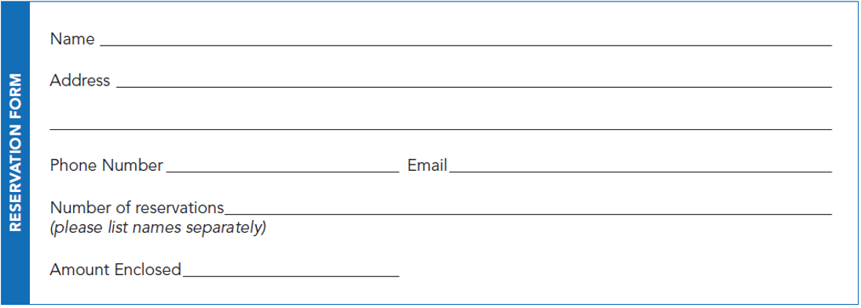
Please send completed form and check for $189.00 each by October 13, 2026 (Payable to St Francis Academy Alumnae Association) to: SFA Alumnae Association, PO Box 14590 Pittsburgh PA 15234. First come first served! Please contact Maria by text or call (412) 874-1188, or email mariaa@lesker.com with any questions.

