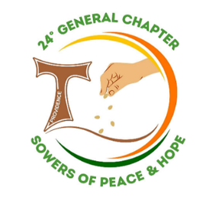
April 2026 Community News

Sisters of St. Francis
of the Providence of God

December 2025



\

Calendar

April 02 Holy Thursday
April 03 Good Friday – Admin. Office Closed
April 04 Holy Saturday
April 05 Easter Sunday
April 08 General Leadership Meeting
April 09 LCWR Zoom – S. Joanne
April 14 MCR Board Meeting
April 15 Future Planning Meeting
April 21 Investment Committee Meeting
April 26 SFA Tulip Luncheon
April 28 Franciscan Fest Meeting – 6:00 pm

Birthdays /Feastdays

April 02 Ir. Margarida B
April 03 Ir. Deise B
April 04 Sr. Peg B
April 11 Ir. Maristela B
April 17 Sr. Francine B
April 17 Ir. Maria José B

./ h+ij




UISG Invites Worldwide Prayer for Peace

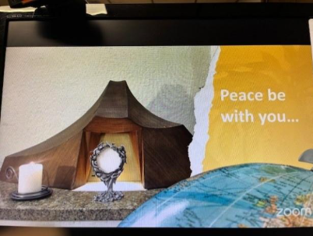
In the face of escalating violence and war, affecting numerous regions of the world, the International Union of Superiors General (UISG), representing more than 1,900 congregations of consecrated women religious present on six continents, called for prayer, fasting, and action for an unarmed and disarming peace.

The UISG brings together nearly 600,000 sisters worldwide, convened an international moment of prayer on Friday, March 6, at 9:30 am EST that was livestreamed and open to the faithful and all people of goodwill.

“As consecrated women religious, present in the most fragile contexts of society and close to those who suffer, we cannot remain silent in the face of a spiral of destruction that undermines human dignity and jeopardizes the future of new generations,” says Sr. Roxanne Schares, SSND, Executive Secretary of UISG.

A few of us were able to participate in this prayer which had reflections in six languages, moments of quiet and musical background that enhanced the global celebration of this prayerful time.

LCWR Author Series - Room in Your Heart for the Unimaginable

As part of the celebration of LCWR’s 70th Anniversary, they have been sponsoring the Author Series Presentations which have been excellent. James Finley, Elizabeth Johnson and most recently Margaret Wheatley have shared affirming and challenging words for women religious. The quote below was shared by Margaret Wheatley ten years ago at an LCWR Conference – it is still challenging today.

Sisters Joanne, Janet, Janice and Mary Ann have been participating in these contemplative moments. These sessions are available on the LCWR website, they are wonderful ongoing formation resources.

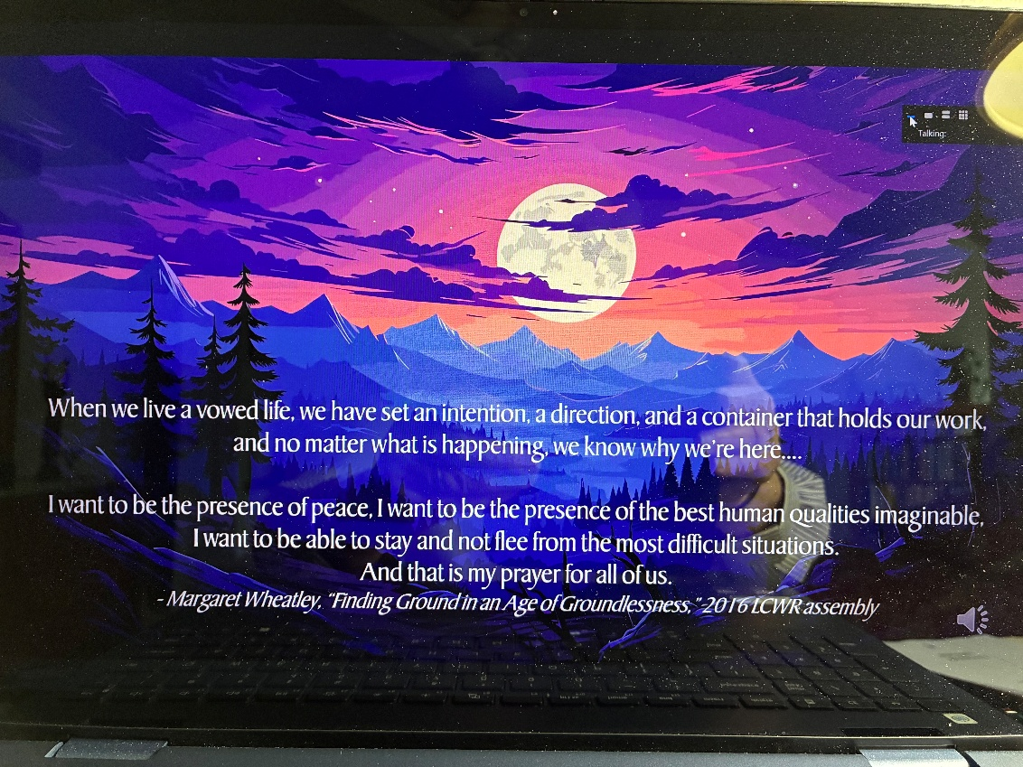

A special note of THANKS from our Jubilarians in Brazil
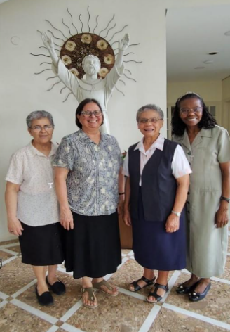
When we were together for our January 24th gathering we wrote cards for those who were to celebrate Jubilees on March 8 in Brazil.

Sister Odete (65 Years) and Sisters Rute, Maria José da Conceicão and Carmem (40 Years) had a lovely celebration and asked that I convey their gratitude to all of you for the congratulatory notes and your solidarity in prayer.

Catholic Sisters Week - March 8 – 14, 2026
The week began with a special liturgy at St. Germaine Church with the parishioners of Our Lady of Hope Parish. Father John Skirtich, the pastor, invited the Sisters who are present in the parish (Sisters of St. Francis of the Providence of God, the Sisters of Charity and Sister Mindy Welding, IHM) to the Eucharistic Celebration at 10:30 am and luncheon afterwards.

During the Eucharist Father John gave a special blessing to the Sisters and expressed gratitude for their presence in the parish.
A tasty luncheon was served by the Ladies of Charity and Christian Mothers; great conversation with one another and the three priests of the parish was enjoyed.

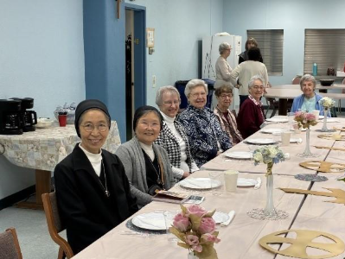
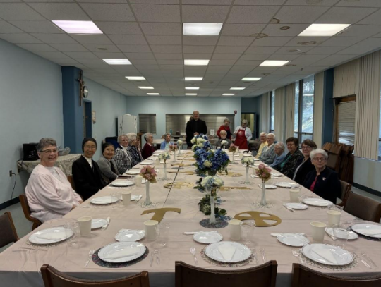

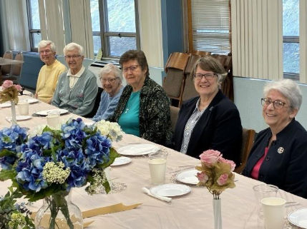

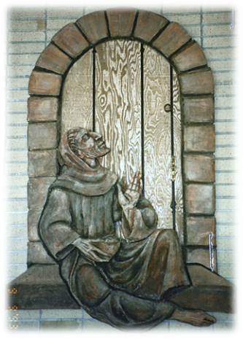
Community Day Celebration
As we celebrated March 12 and remembered our rich history, we were united in prayer with one another and our Sisters in Brazil as we gave thanks for the gift of God’s Providence as well as for the many people who have been part of our story.

Affirming and challenging words from Sister Rute, our General Minister, reminded us of our commitment to live the gospel.

We Believe…We Remember…We Celebrate

Fish Fry at St. Valentine’s
As part of the weeklong activities for Catholic Sisters Week (March 8-14), we were treated to the St. Valentine’s Fish Fry, compliments of the Teen Leadership Corps of the Our Lady of Hope Parish.
Once again we enjoyed one another’s company and that of the Sisters of Charity. The fish/shrimp meals were delicious and the hospitality and service most gracious.
Our Lady of Hope Parish CCD also treated us with a basket of treats.
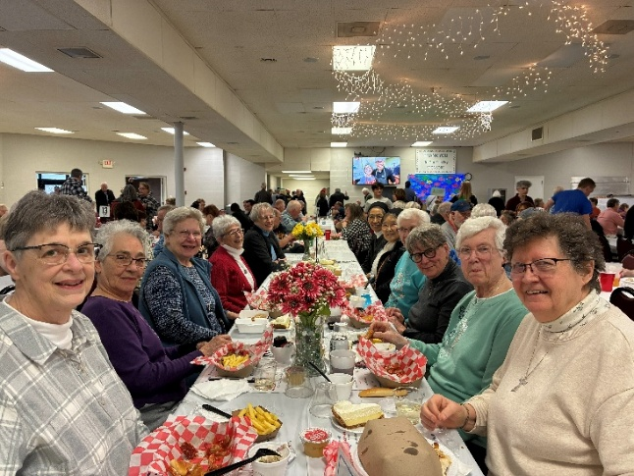

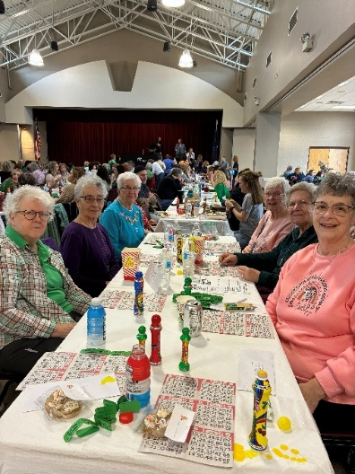
Super Bingo
On Sunday, March 15, Annette Yousko, our Auxiliary President, treated six of us to a special bingo at the Bethel Park Community Center. The proceeds went to Bailey’s Cat Haven in South Park where Annette volunteers.
Although we didn’t win on Bingo, fun was had by all!

Morning Prayer of Compassion and Dignity
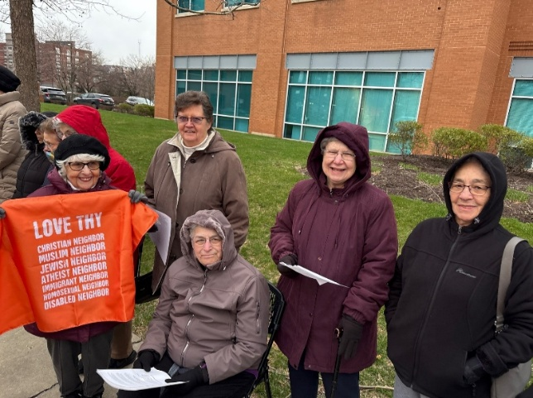
Since the national theme for Sisters Week this year is Stories of Hope and Heart stressing the focus toward deep compassion, courage, prayer and service, the women religious of the diocese of Pittsburgh decided as a corporate action to join those who regularly gather on Fridays at 8:30 – 9:30 am outside the ICE Detention Center on the South Side.

Robyn Moeller, our Development Director, Joan Ammon, our Associate, and Sisters Eliana, Janet and Joanne participated in this event with more than 150+ others to pray for those who have been detained in ICE facilities and those who have died in them. The Sisters of St. Joseph had prepared the reflection which named the 43 immigrants who have died this year in ICE custody.
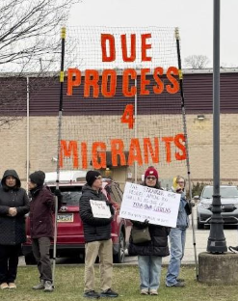
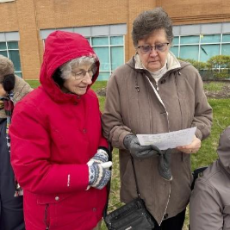

Remembering Carol Stasik

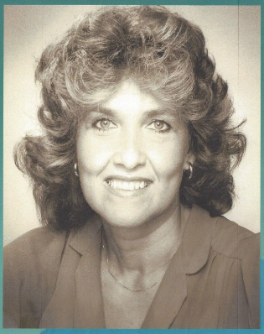
Sisters and Associates gathered on Saturday, March 14 with some of Carol Stasik’s family to remember and thank God for her life. Carol was an associate for many years and always had something to contribute. She died on December 21, 2025.

It was such a gift for all to be together and remember this incredible woman of faith.

May she rest in peace!
Celebrating Roots – An Afternoon with the Sisters of the Holy Family

On Wednesday, March 18, Sisters Joanne and Janet hosted eight Sisters of the Holy Family of Nazareth. Two of their General Councilors, Sister Alina Furczyk and Sister Amabilis Sikora were visiting from Rome, Italy as well as the Provincial Superiors from Poland, Sister Wieslawa Hyzinska, from Warsaw, Sister Julitta Tlustowska, from Krakow, the Provincial from Belarus, Sister Filotea Tichonowicz, and Sister Beata Wilk from Ukraine. The Provincial Superior, Sister Thea Krasue from the Holy Family Province in Duncansville, PA and the Former Provincial, Sister Cynthia Meyer, were hosting the Sisters for some days in the area.

Sister Cynthia is in the process of writing the history and they wanted the opportunity to hear from us about the beginning of our congregation.
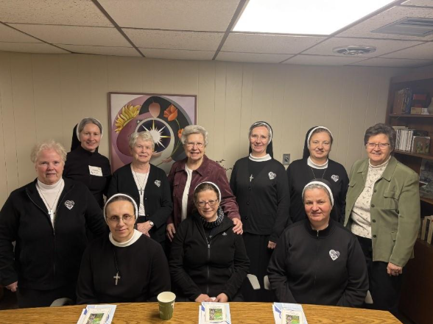

(Front row) Sister Thea Krause, CSFN (Standing), Sister Filotea Tichonowicz, CSFN,
Sister Alina Furczyk, CSFN, Sister Julitta Tlustowska, CSFN

(Back row) Sister Amabilis Sikora, CSFN, Sister Cynthia Meyer, CSFN, Sister Joanne Brazinski, OSF,
Sister Wieslawa Hyzinska, CSFN, Sister Beata Wilk, CSFN, and Sister Janet Gardner, OSF

Retreat with Father Charles Speicher – An Anawim Experience
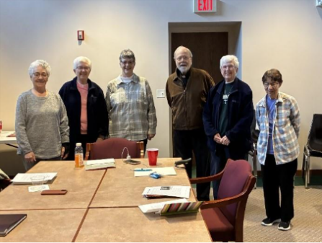
Saturday, March 21, 2026, the Sisters of Saint Francis of the Providence of God gathered for a reflection day with the theme: Living with Gratitude and Joy. Although we had planned for 11 or 12 members to be there, the Anawim of six certainly profited from the reflection by Father Charles Speicher from Our Lady of Hope Parish. He presented the group with practical everyday wisdom about living gratefully and joyfully. His humor always seems to make the message stick!
No Kings Rally
On Saturday, March 28 Sister Janet Gardner, Joan Ammon, one of our Asociates and Mike Stasik , husband of Carol Stasik, our Associate who passed away in December, attended the No Kings Rally in Pittsburgh. It was just one of 3,300 that were held all across the country and other parts of the world as a peaceful protest of the current USA Administration’s policies and actions. Per the mayor of Pittsburgh, Corey O’Connor, there were between 15,000-20,000 people at the rally as part of the estimated 8 million people that gathered worldwide.

