Mass 2025
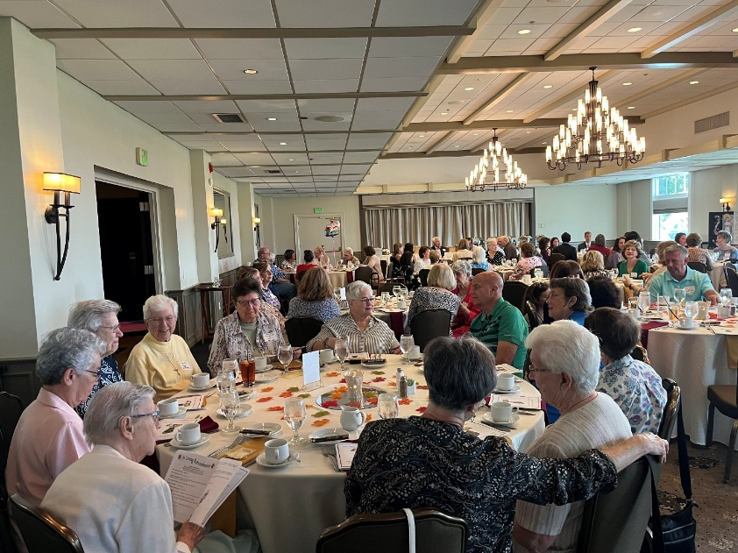
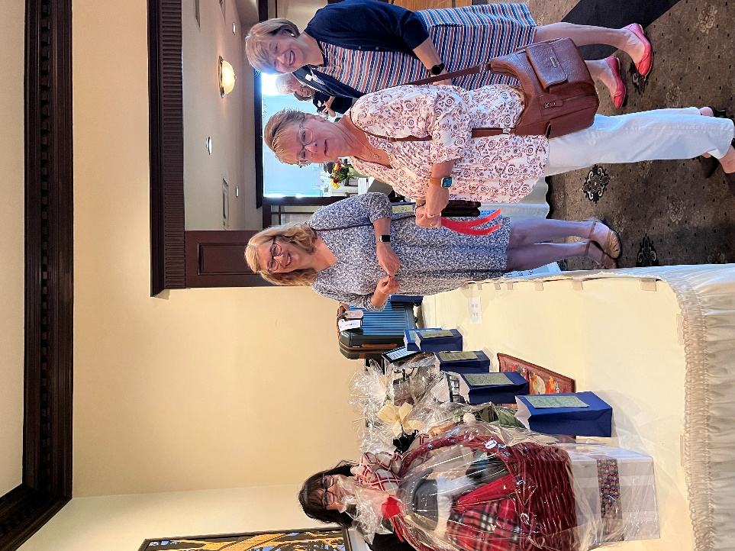
Left to Right: Maria Ammon ’84, Joan Antoniazzi Greene ’76, Mary Gordon Tinko ’78, and Kathy Antonizzi ‘76
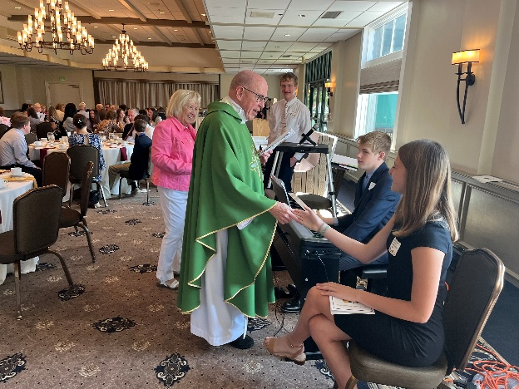 Eli Jacobs – Senior, Clare Horne Rex – Scholarship Chair, Collin Jacobs – Sophomore, Fr Cain, Annabelle Watson – Sophomore
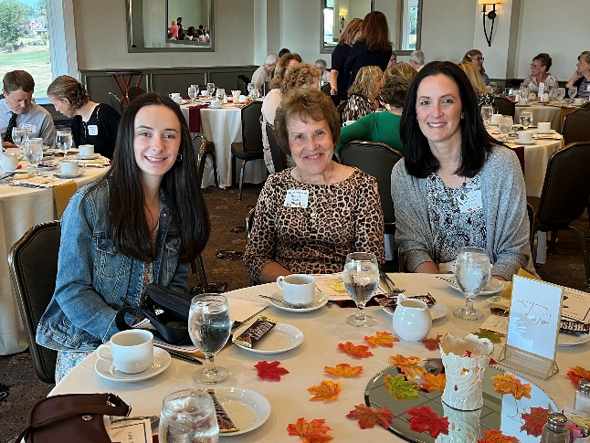
Left to Right: Scholar Natalie Pascarella – sophomore, SFA Membership Chair, DeDe Metro, Allison Pascarella (DeDe’s daughter and Natalie’s Mom)
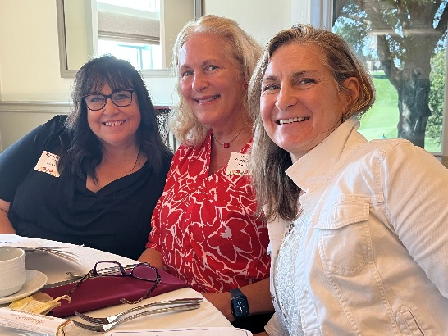
Class of ’84 - Left to Right: Maria Ammon, Lucy Loy Santella, Yvette Rose Casdorph
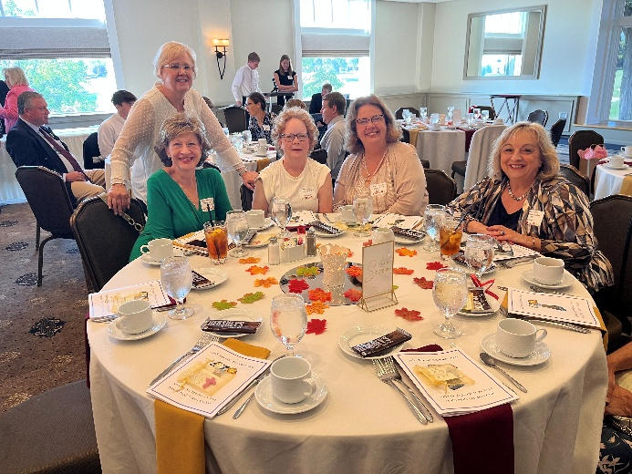 Class of ’72 Left to Right: Patti McVay Thearle (standing), Dee Kosmack Hartlep, Kathleen Grasmik Wirth, Janet Hillgrove Werme, Michelle Petri

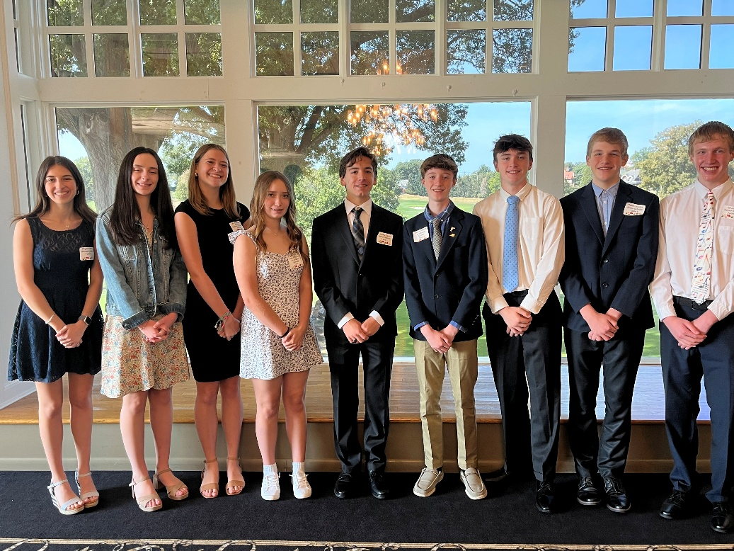
From left to right:
Megan Harris – Senior, Natalie Pascarella - Sophomore, Annabelle Watson- Sophomore, Jillian Pastirik – Freshman, James Darcy – Senior, Samuel Mozes - Freshman, Paul Farnan – Junior, Collin Jacobs – Junior, Eli Jacobs – Senior.

